MACH4METAL

Metalworking machinery
Transito 21,
6909 DA BABBERICH
Netherlands
Tel. +31 (0)316 – 247123
Fax. +31 (0)316 - 247956
info@mach4metal.com
www.mach4metal.com

Account No: 66.52.13.883
IBAN : NL33 INGB 0665 2138 83
BIC : INGBNL2A

TOS VARNSDORF WHN 110 Q MC
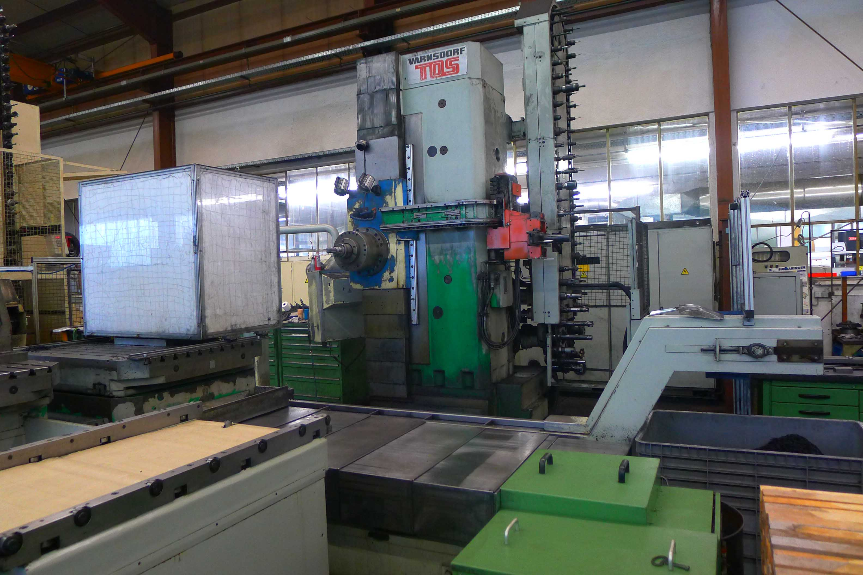
- Make : TOS Varnsdorf
- Typ : WHN 110 MC
- Serial : 2
- Age : 1994

- Spindle : iso 50
- Diam : Ø 112
- Power : 37kW
- Speeds : 2500 Rpm

- X : 2.000
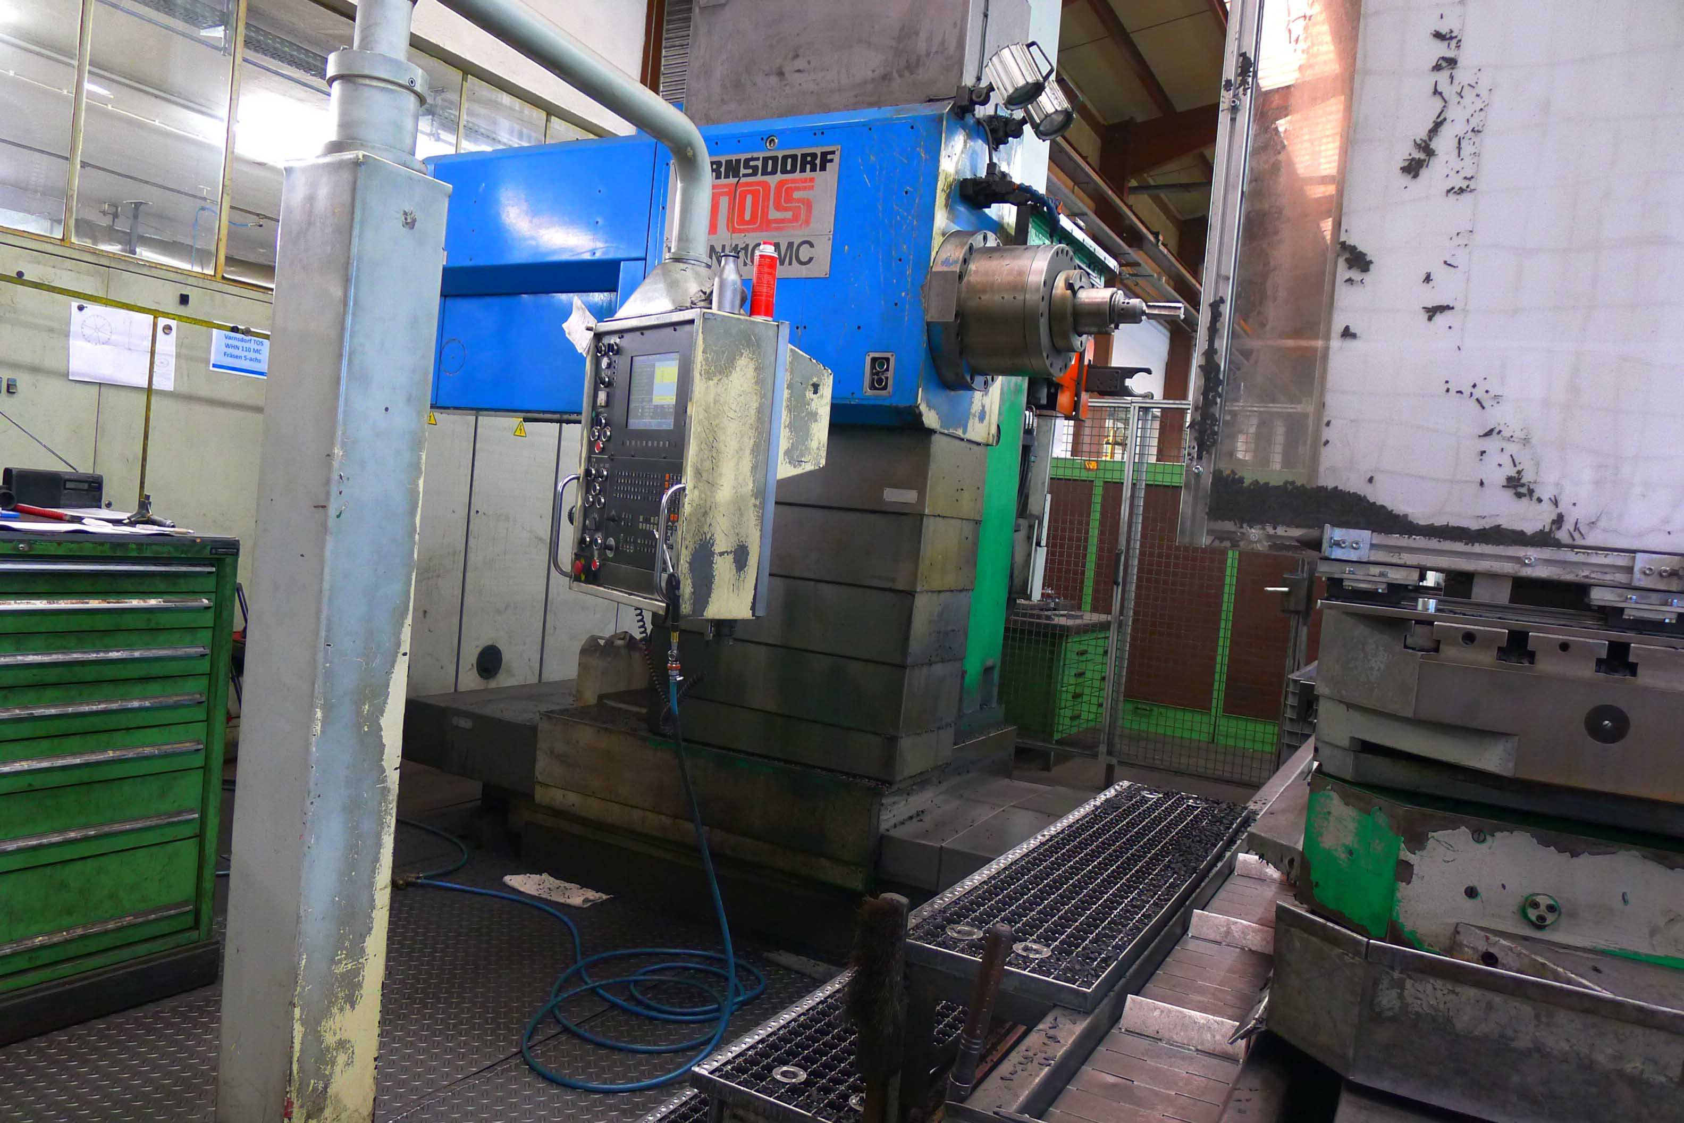
- Y : 1.400
- Z : 1.250
- W : 500

- Table size : 1.400 x 1.250
- Load on table : 5.000 Kg
- Feeds X,Y,Z : 5.000 mm/min.
- Rapid : 10.000 mm/min.

- ATC Chain 60 positions
- CNC Dr. HeidenHain TNC 415 5 Axis
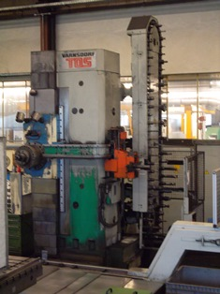
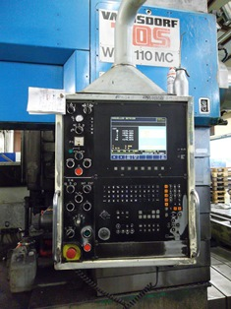
- Hand wheel remote
- Chip conveyor
- Pallet changer

- Length : 4.840
- Width : 7.950
- Height : 4.550
- Weight : 27 T

Please Note: The above information has been obtained to the best of our ability and belief from, and from the manufacturers where possible. It is given in good faith, but its accuracy can not be guaranteed. Accordingly, it will not form a representation or constitute contractual terms. We advise you to check any vital details!

